**SAVEETHA SCHOOL OF ENGINEERING**

**CAPSTONE PROJECT**

**Advanced routing protocol for dynamic routing**

**NAME:** Balaji.K

**REGISTER NUMBER:** 192324 255

# COURSE CODE: CSA0747

**COURSE NAME:** Computer Network for IOT

**INTRODUCTION:**

In healthcare networks, reliable and efficient data communication is critical for applications like electronic health records (EHR) and telemedicine. Dynamic routing protocols such as OSPF (Open Shortest Path First) and EIGRP (Enhanced Interior Gateway Routing Protocol) enhance network performance by optimizing data paths and adapting to network changes. This project focuses on implementing these protocols to improve the efficiency and reliability of healthcare networks.

**Objective**

1. **Design a Network Topology:** Create a network topology incorporating dynamic routing protocols to optimize connectivity and data flow.
2. **Implement Routing Protocols:** Configure OSPF or EIGRP for dynamic and efficient routing.
3. **Optimize Performance:** Analyze and enhance network performance with the chosen protocols.
4. **Evaluate Effectiveness:** Assess the impact of the protocols on network reliability and scalability.

**LITERATURE REVIEW**

OSPF is a link-state protocol using the Dijkstra algorithm for efficient routing within an Autonomous System, known for its scalability. EIGRP is a distance-vector protocol that uses the Diffusing Update Algorithm (DUAL) for fast convergence and loop-free routing, favored for its ease of use in smaller to medium-sized networks. Both protocols have distinct advantages based on network size and complexity.

# METHODOLOGY

**Software:**

* Cisco Packet Tracer **Network Design:**

**Components used:**

* PC-6
* Switch-3
* Router-3

1. **Network Design:** Develop a topology suited for healthcare applications and choose the appropriate protocol (OSPF or EIGRP).
2. **Implementation:**
   * **OSPF:** Configure areas, interfaces, and authentication.
   * **EIGRP:** Set up autonomous systems, networks, and authentication.
3. **Testing and Verification:** Conduct tests to validate protocol functionality and troubleshoot any issues.
4. **Optimization:** Monitor and adjust network settings to improve performance and reliability.

**Network Design:**

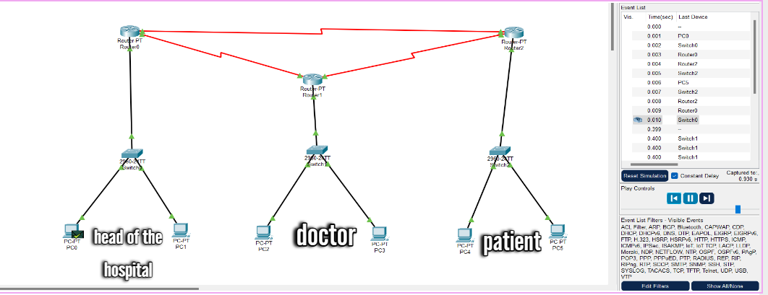

**CONCLUSION:**

Implementing OSPF or EIGRP significantly enhances the performance and scalability of healthcare networks. Proper configuration and testing ensure efficient routing and reliable connectivity, supporting the high demands of healthcare applications. This approach ensures a robust network infrastructure that meets the needs of modern healthcare environments.